NAME: _______________________, Sect. #_______

Physics 109 Homework # 1
due Monday, September 18, 2001

- Prefixes for large numbers are k for kilo (1000), M for mega (10⁶) and G for giga (10⁹).
- Prefixes for small numbers are m for milli (10⁻³), μ for micro (10⁻⁶), and n for nano (10⁻⁹).
- Weight of a mass depends on how strong gravity is at that location. On earth, the acceleration of gravity is g = 9.8 m/s². The weight is figured as w = mg.
- spring constant k is related to force F and elongation (stretching) x by F = kx.

- A dog can hear frequencies up to 40,000 Hz
- express this frequency in kHz.

- find the period of this oscillation. Express the answer in s, in ms and in μ s.

- If Jim has a mass of 70 kg, how much many Newtons does he weigh on earth where the acceleration of gravity is g= 9.8 m/s²?

if Jim is on the moon where the acceleration of gravity is only 0.15 m/s², how much will
he weigh?

- for the oscillation on the right, the
horizontal axis (time) is in msec.

find the period T in sec and in msec:

T =

find the frequency in Hz and in kHz:

f =

find the amplitude

A =

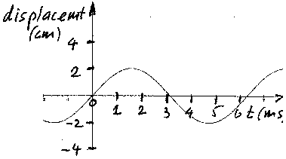

- The length of a spring is measured for different pulls F:

pull F: 2N 4N 6N 8N 10N
length of spring: 20cm 25cm 30cm 35cm 40 cm

Find the spring constant in N/cm and in N/m

5. For simple harmonic motion (mass on a spring) the frequency is the same, no matter whether the amplitude is large or small.

