NAME: _______________________, Sect. #_______

Physics 109 Homework # 2
due Monday, September 24, 2001

- Damping time: a guitar string has a frequency of 260 Hz (middle-C) and a damping time of 2 sec.
- How many oscillations does the string make before the amplitude has decreased to half of the original value?

- if the initial amplitude of the guitar string was 2 mm, how large will be the amplitude
after 2 sec? __________ after 4 sec? ___________ after 8 sec?____________

- In the lecture demo we found that a 2 kg mass oscillating up and down on a spring
made 10 oscillations in 5 sec, which corresponds to a frequency of _________ Hz.
What would have been the frequency if the 2 kg mass was replaced by a 4 kg mass?
(hint: look at the SHO frequency formula and use proportions like we did in lecture).

What would have been the frequency if the 2 kg mass was replaced by a 1 kg mass?

3, The graph shows the pressure variations
from two separate tuning forks.

Show the superposition of the two
oscillations, i.e. the pressure variation
when both tuning forks oscillate at the
same time.
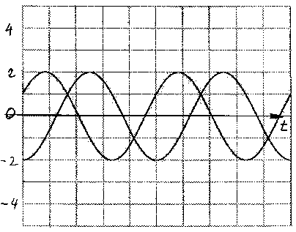

- Beats: A tuning fork has a frequency of 440 Hz. What are the possible frequencies of a second tuning fork if, when both forks are sounded together, they produce 4 beats every second?

- A simple harmonic oscillator has a natural frequency of 200 Hz. The damping time of the oscillator is 40 ms.
A periodic force is applied to the oscillator.
- For what frequency of this force does one observe the largest amplitude of oscillation?

- about how many Hz would the frequency have to be raised or lowered to get half as much amplitude of the oscillator?

- When one plots a resonance curve, the horizontal axis shows what quantity?

The horizontal axis shows________________________________________

____________________________________________________________

The vertical axis shows what quantity?

The vertical axis shows _________________________________________

___________________________________________________________

Based on the above make an approximate drawing of the resonance curve.
